Machine Utilisation Analytics: Enhancing Efficiency and Reducing Costs in Manufacturing Operations

# Executive Summary

## Brief Overview of the Solution:

Machine Utilisation Analytics (MUA), an advanced data analytics tool, seeks to provide comprehensive insights into the manufacturing equipment's operational performance. This technology gathers real-time machine performance data via power monitoring sensors and analyses it using sophisticated data analytics pipelines. The analysis centres on important metrics, including machine utilisation percentage, energy consumption cost, product count, production duration, and the ability to recognise various manufactured product types.

Through the use of cloud-based data processing and Wi-Fi-connected sensors, MUA connects with the existing production infrastructure. Through user-friendly dashboards and reports, the installation process is non-intrusive and provides immediate operational insights.

Our approach successfully distinguishes between three important machine states: machine off, machine idle, and machine working time — using machine learning methods and clustering methodologies. This precise classification allows manufacturers to pinpoint inefficiencies, track operator performance, and streamline production processes with unparalleled accuracy.

## Key Benefits and Value Proposition:

MUA delivers significant advantages to manufacturing companies, including but not limited to:

### Optimisation of Machine Operation:

By decreasing idle times, improving overall efficiency, and monitoring machine performance in real-time, the solution assists businesses in making the best use of their machinery. Operational parameters can be fine-tuned for better optimisation by offering comprehensive insights into various machine states, such as off, idling, low intensity, and high intensity. This ultimately results in more effective resource utilisation and enhances the productivity of manufacturing processes.

### Energy Consumption Cost Management:

MUA measures energy consumption, allowing the calculation of energy costs associated with machine operations. Businesses can pinpoint high-energy-consuming tasks and put policies in place to cut energy use, which will lower operating expenses. Through the promotion of effective resource management, this thorough understanding of energy usage also aids sustainability activities.

### Enhanced Decision-Making:

The solution offers data-driven support for important decisions regarding machine procurement, production scheduling, and cost estimation. It provides detailed insights into production trends and machine performance, enabling strategic planning and well-informed decision-making. This increased ability allows companies to meet market demands better, optimise production schedules, and allocate resources more efficiently.

### Productivity Measurement:

With this solution, it is possible to monitor key productivity metrics, such as product count and production duration, to show production efficiency clearly. By identifying patterns in production cycles, companies can enhance forecasting accuracy and improve resource allocation. This comprehensive productivity measurement contributes to achieving higher output levels and maintaining consistent production quality.

### Anomaly Detection:

Detecting irregularities and anomalies in machine performance is a beneficial feature of the Machine Utilisation solution, which helps in timely maintenance and reducing downtime. This proactive maintenance approach supports predictive maintenance strategies, leading to extended machine life and consistent production quality. Companies can minimise disruptions and maintain smooth operational flow by addressing potential issues early.

### Operation Benchmarking:

The solution allows for comparing manufacturing operations against industry standards and internal targets, making it easier to identify improvement areas and enabling companies to improve continuously. This benchmarking capability fosters a culture of excellence and aids in maintaining a competitive edge.

### Quality Assurance and Compliance:

Monitoring production processes through MUA helps to uphold quality standards. The comprehensive data collected aids in meeting both industry regulations and internal quality control measures. Companies can consistently deliver high-quality products and maintain customer satisfaction by ensuring production processes comply with established standards.

### Scalability and Flexibility:

The solution is designed to quickly expand and adapt to additional machines and production lines as a business grows. Its adaptable configuration options enable it to adjust to various manufacturing environments and requirements, ensuring its relevance and effectiveness in diverse operational contexts. This scalability and flexibility make it a wise long-term investment for any manufacturing company.

# Solution Description

## Detailed Description of the Power Monitoring Solution

MUA is a sophisticated solution designed to monitor, analyse, and optimise machine utilisation in manufacturing environments. This solution leverages state-of-the-art sensor technology, robust data processing pipelines, and advanced machine learning algorithms to provide actionable insights into machine performance and energy consumption. Below, we delve into the methodology employed, technical specifications, and components involved in this comprehensive data analytics solution.

## Methodology

This section describes the detailed approach used for creating and executing the data analytics solution for analysing machine usage and production trends in the manufacturing sector. The approach covers the data gathering process, sensor technology, data manipulation, and the utilisation of machine learning algorithms and clustering methods to derive valuable insights from the acquired data.

### Data Collection and Sensor Technology

In the initial phase of the methodology, data is collected regarding the functioning of the machinery and its energy usage. A non-invasive power monitoring sensor is employed, featuring a clamp that is securely affixed to the machinery power cable. This sensor captures real-time electrical current data, generating a continuous time series dataset that offers an in-depth insight into the machinery's energy consumption patterns. The usage of a clamp-on sensor ensures that the setup is non-disruptive and doesn't necessitate any alterations to the existing electrical framework of the machinery.

### Data Transmission to MDEP

After being gathered, the information is sent to the Manufacturing Data Exchange Platform (SMDH cloud platform) for smooth storage and processing. An IoT gateway device is set up with MQTT protocol to transmit real-time data to the cloud securely. This arrangement guarantees that the data is under constant surveillance and is easily accessible for analysis, facilitating prompt insights and decision-making.

### Activity Detection using Machine Learning Algorithms

The preprocessed data is subjected to machine learning algorithms to identify machine utilisation patterns. Supervised learning techniques are employed to train a model that classifies machine states into three categories: machine off, machine idling, and machine working time. The model is trained on the data acquired for at least two weeks to identify the threshold for the different machine states automatically. This classification enables a detailed understanding of machine operation and downtime.

Automation of Threshold Creation

The creation of thresholds to distinguish machine idling from operation periods is automated using a Gaussian Mixture Model (GMM). This statistical technique effectively segments the data into distinct clusters, enabling the determination of appropriate thresholds for different machine states. The automated threshold creation eliminates the need for manual intervention and ensures accurate identification of machine activities, enhancing the reliability of the analysis.

Clustering Techniques for Production Segmentation

Clustering techniques are used to analyse the time gaps between instances of product creation, aiming to understand production dynamics and uncover production patterns. Unsupervised learning algorithms like DBSCAN (Density-Based Spatial Clustering of Applications with Noise) are employed to divide production data into different categories, helping to pinpoint typical production durations and identify any unusual instances that might reveal potential quality control problems or unique production cases.

### Cost Estimation and Resource Allocation

The data analytics solution incorporates time-of-use tariffs to estimate costs and optimise resource allocation. By combining machine utilisation insights with tariff information, the solution provides manufacturers with detailed cost breakdowns. This allows them to make informed decisions regarding resource allocation during different shifts and days of the week, ultimately optimising operational efficiency and reducing energy costs.

## Technical Components Involved

The technical specifications and components involved in the MUA solution are detailed below:

1. **Power Monitoring Sensor**: The machine's power cable is monitored by a power monitoring sensor that collects real-time electrical current data. This sensor can be easily installed without disrupting machine operations and provides continuous data.
2. **An IoT Gateway**: The sensor data is collected by the gateway device, such as the Raspberry Pi Computer, and then sent to the cloud platform.
3. **AWS Cloud Platform (MDEP)**: Utilised for data storage and processing, ensuring that data is securely stored and readily available for analysis. The platform supports scalable data processing pipelines, allowing for handling large datasets in real-time.
4. **Data Preprocessing Tools**: These include AWS services, software libraries, and algorithms for data wrangling. These tools ensure that the data is of high quality and suitable for further analysis.
5. **Machine Learning Algorithms**: Unsupervised learning algorithms for activity detection and unsupervised learning algorithms for clustering. These algorithms are essential for extracting meaningful insights from the data and automating the identification of machine states and production patterns.
6. **Visualisation Tools**: A user-friendly dashboard and visualisation tools that make it easy for users to access and comprehend data conveniently. Customised reports offer valuable insights to address specific business needs, enhancing the solution's effectiveness.

# Implementation Process

The MUA solution's implementation is meant to be simple and effective, ensuring minimal interference with current manufacturing operations. The implementation process begins with structured discussions and advances through installation, data collection, analysis, and ongoing support.

The initial phase of the implementation process involves an initial dialogue between the manufacturing company and our technical team. In this phase, the specific demands and goals of the company are addressed, which results in the development of a customised implementation plan. This plan describes the project's objectives, scope, and the equipment that will be observed.

Following the consultation, the power monitoring sensors and detailed installation guides are delivered to the company. The sensors, designed for non-intrusive installation, are easily clamped around the power cables of the selected machines. The company's maintenance staff can typically complete this straightforward installation process without needing specialised training.

After the sensors are set up and ready, the process of collecting data starts. Continuous real-time data transmission on machine operations and energy usage to the cloud platform occurs. During this phase, our technical team provides remote support to ensure the data is correctly captured and transmitted. Any initial issues with data quality or transmission are promptly addressed to ensure the integrity of the data collected.

The next step involves data processing and analysis, with the data collection underway. The collected data is preprocessed to clean and normalise it, ensuring it is ready for analysis. Machine learning algorithms are then applied to classify machine states and identify utilisation patterns. The raw data will be processed throughout this stage to generate valuable insights that can improve operations. Processing and analysing the data will take several weeks, with initial insights expected in a month. Subsequently, a comprehensive report and user-friendly dashboards will be developed and presented to the company.

The analysis findings will be communicated to subject matter experts (SMEs) via interactive dashboards, offering a complete overview of machine performance and energy consumption. Additionally, continuous support will be available to address any questions or concerns, ensuring that the company maximises the benefits of the MUA solution.

# Results and Insights

## Key Findings from the Data Analysis

Implementing the MUA solution has given manufacturing companies critical insights into their machine operations and energy consumption patterns. The solution has provided an in-depth insight into machine usage, energy expenses, and production patterns through real-time data gathered from power monitoring sensors.

An important discovery is the ability to categorise machine states, which include off, idling, low-intensity, and high-intensity operations. Manufacturers can detect inefficiencies through this classification, such as extended periods of inactivity or sudden increases in energy consumption, and implement the appropriate corrective measures. For example, data analysis showed that some machines idled excessively during particular shifts, which prompted more research and shift schedule optimisation to reduce idle time and boost productivity.

Another significant insight relates to energy consumption patterns. The solution has given a comprehensive view of energy consumption across various operational phases, enabling companies to grasp the financial impact of their equipment operations. This data is essential for pinpointing opportunities to save energy. For example, manufacturers can move energy-intensive operations to non-peak hours by examining energy usage data in conjunction with time-of-use tariffs, leading to significant cost reductions.

Additionally, machine learning algorithms have allowed the identification of distinct production patterns. The solution can segment production data into meaningful clusters by analysing the time elapsed between product creation instances. This capability is invaluable for distinguishing between different product types and assessing the production duration for each type, helping to optimise production schedules and improve resource allocation.

### Examples of Insights Gained

The data analysis has provided several actionable insights. For example, a detailed examination of the time series data showed frequent short-duration idle periods for specific machines. This finding led to workflow adjustments that reduced idle time and increased overall machine utilisation.

Energy consumption cost management was another area where significant insights were gained. By analysing energy usage data, manufacturers were able to identify peak consumption periods and implement strategies to shift operations to less costly times. This reduced energy costs and contributed to more sustainable energy use practices.

The solution's ability to classify machine states also facilitated the detection of anomalies indicating potential maintenance issues. Unexpected spikes in energy consumption or prolonged idle times were flagged, prompting timely maintenance interventions that prevented costly breakdowns and ensured consistent production quality.

## Dashboard and Reporting

Description of the Visualization Tools and Dashboards Used

MUA employs robust visualisation tools and interactive dashboards, primarily powered by Amazon QuickSight. This solution is intended to display intricate information in a format that is easy for users to understand and act upon, allowing stakeholders to comprehend insights and make prompt, educated decisions. The purpose of this solution is to simplify the interpretation of complex data and prompt action, helping stakeholders to absorb vital information and make well-informed decisions swiftly.

The dashboards contain various visual elements, such as pie charts, radar charts, line charts, and bar graphs, with each one uniquely crafted to emphasise specific aspects of machine performance and energy consumption. These visualisations provide a comprehensive view of key metrics, facilitating detailed analysis and continuous monitoring of machine operations.

Examples of Reports and Dashboards Presented to the Company

**Average Utilisation per Day**: A bar graph showing the average utilisation of the machine on a daily basis, highlighting variations in usage and potential inefficiencies that can be addressed. For example, consistent underutilisation on certain days may indicate the need for workflow adjustments.

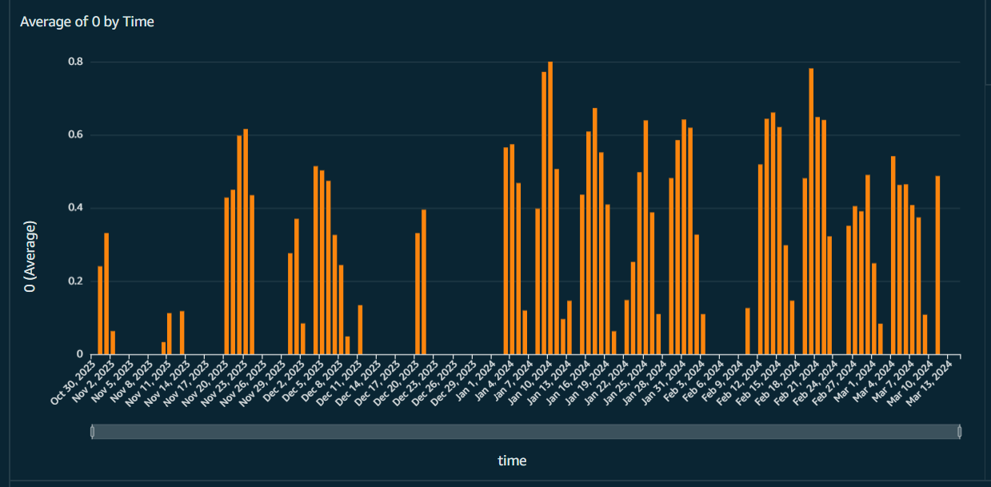

**Machine State Distribution**: A pie chart illustrating the percentage of time a machine spends in various states, such as off, non-productive, low intensity, and high intensity. This visualisation helps in understanding overall machine efficiency and identifying areas for improvement, such as reducing non-productive time.

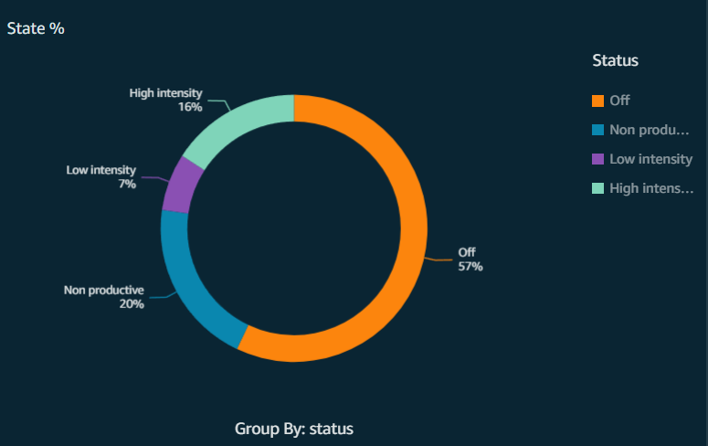

**Machine Utilisation Over Time (Benchmarking)**: This radar chart displays the average machine utilisation percentage over different periods, helping companies identify trends and patterns in machine usage across weeks and months. For instance, the chart may reveal higher utilisation during specific days, prompting further investigation into factors contributing to this variation.

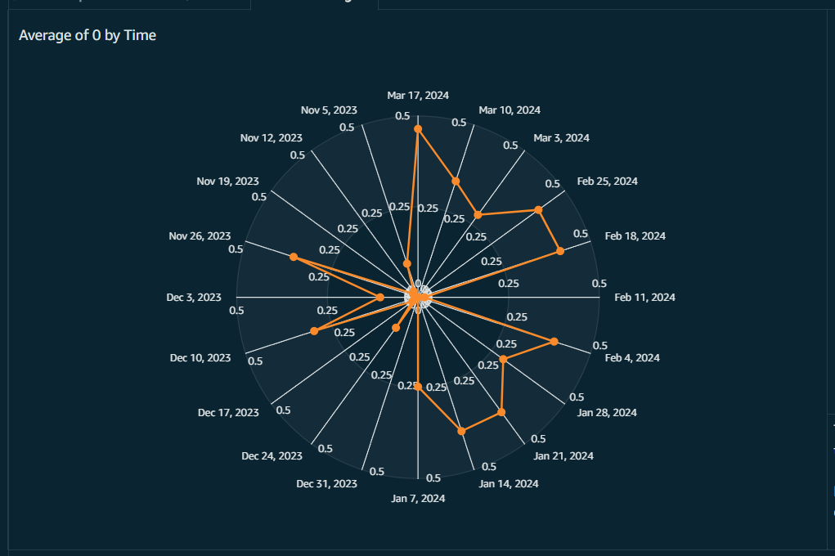

**Energy Consumption and Cost Analysis**: Combining line and pie charts, this dashboard shows the sum of energy usage by date and the total spend on energy, broken down by machine operational states. This visualisation enables companies to track energy costs and identify high-consumption periods, facilitating targeted efforts to reduce energy expenses.

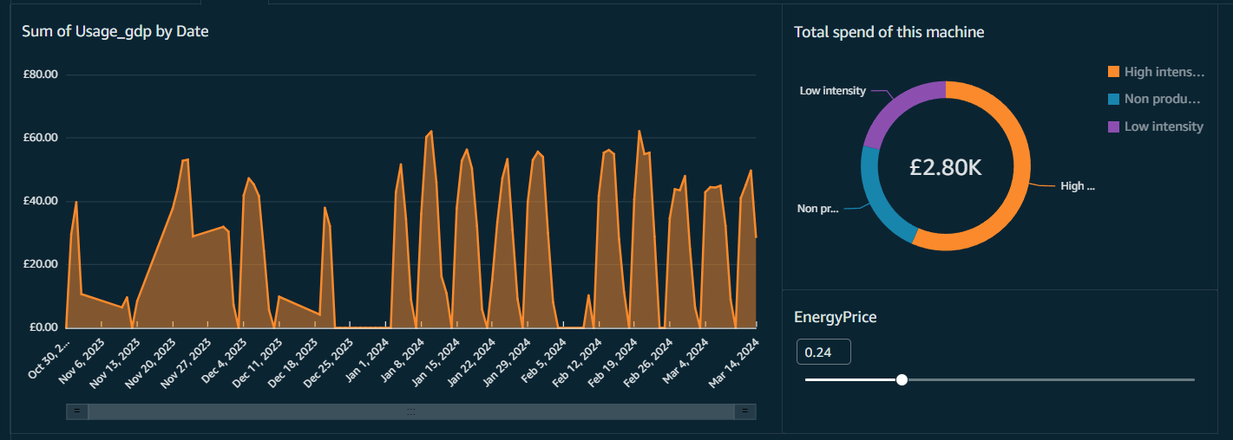

**Product Type Identification and Count**: A set of bar charts that display the number of parts produced by date and product type. This dashboard is particularly useful for tracking production output and identifying deviations from expected production patterns, aiding in resource planning and quality control.

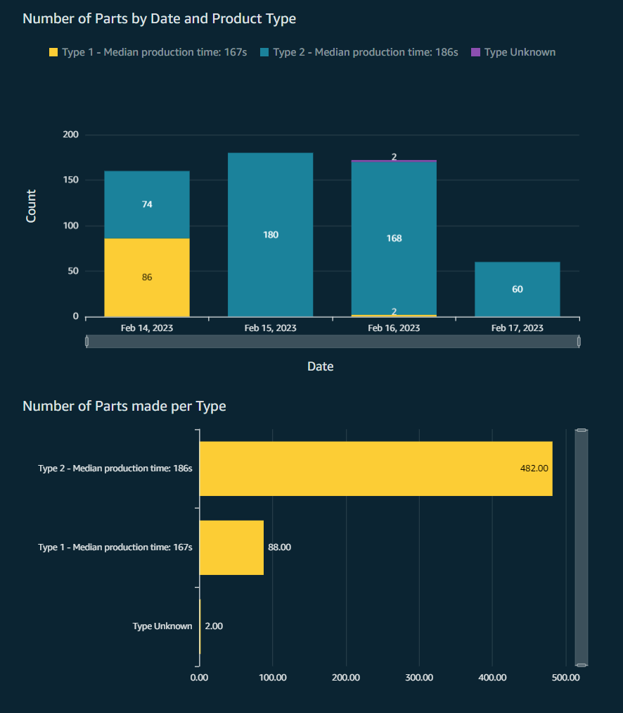

Business Impact and Benefits

The introduction of MUA has resulted in substantial tangible and intangible advantages for manufacturing firms. By delivering real-time visibility into machine efficiency and power usage, the system has spurred enhancements in operations and reduced costs throughout different facets of manufacturing.

Quantitatively, companies have reported substantial increases in machine utilisation rates. For instance, precise data on machine states has enabled manufacturers to reduce idle times and enhance overall efficiency. Using machine monitoring data to identify and address operational inefficiencies has been proven to result in up to a 30% increase in utilisation ([MachineMetrics](https://www.machinemetrics.com/blog/machine-utilization" \t "_blank))​. The solution helps businesses save energy and reduce energy costs by shifting energy-intensive activities to non-peak hours.

Businesses have successfully implemented maintenance programs by gaining a comprehensive grasp of the factors causing both scheduled and unscheduled downtime. Real-time monitoring data supports predictive maintenance, leading to minimised maintenance costs and reduced unexpected breakdowns. This proactive maintenance approach can decrease downtime and improve product quality by optimising machines​ ([Deskera](https://www.deskera.com/blog/manufacturing-analytics-key-metrics/" \t "_blank), [Intuz](https://www.intuz.com/blog/introduction-to-machine-monitoring-use-cases-and-benefits))​.

MUA has significantly improved decision-making abilities within manufacturing organisations through qualitative means. Managers may now act swiftly and decisively with comprehensive dashboards and real-time data. As a result, production schedules are now more sensitive to market demands, and resources are allocated more effectively. The solution's visibility has also improved supply chain management, enabling companies to manage inventory better and reduce lead times ([MachineMetrics](https://www.machinemetrics.com/blog/manufacturing-analytics" \t "_blank), [McKinsey & Company](https://www.mckinsey.com/capabilities/operations/our-insights/manufacturing-analytics-unleashes-productivity-and-profitability))​.

The solution provides comprehensive information and insight that can significantly enhance decision-making. Managers can plan maintenance, allocate resources, and set production plans with the use of precise, up-to-date information. All stakeholders, from operators to senior management, can quickly understand and react to the information when it is presented on user-friendly dashboards. This improves the ability to make decisions, facilitates improved planning, lowers operational risks, and encourages continuous organisational improvement.

# Conclusion

Because MUA provides real-time insights into machine performance, energy usage, and production efficiency, it has dramatically improved manufacturing processes. The approach has resulted in significant energy savings, decreased downtime, and increased machine utilisation. Furthermore, it has bolstered decision-making based on data, improving the allocation of resources and manufacturing processes. Manufacturers have enhanced their competitive edge by employing advanced data analytics and easy-to-use dashboards, reduced costs, and boosted operational efficiency. MUA is a transformative tool that drives sustainable growth and continuous advancement in the manufacturing industry. Through the promotion of effective resource management, this thorough understanding of energy usage also aids sustainability activities.